Click on the links on the school website or enter https://www.edplace.com/ into your address bar.
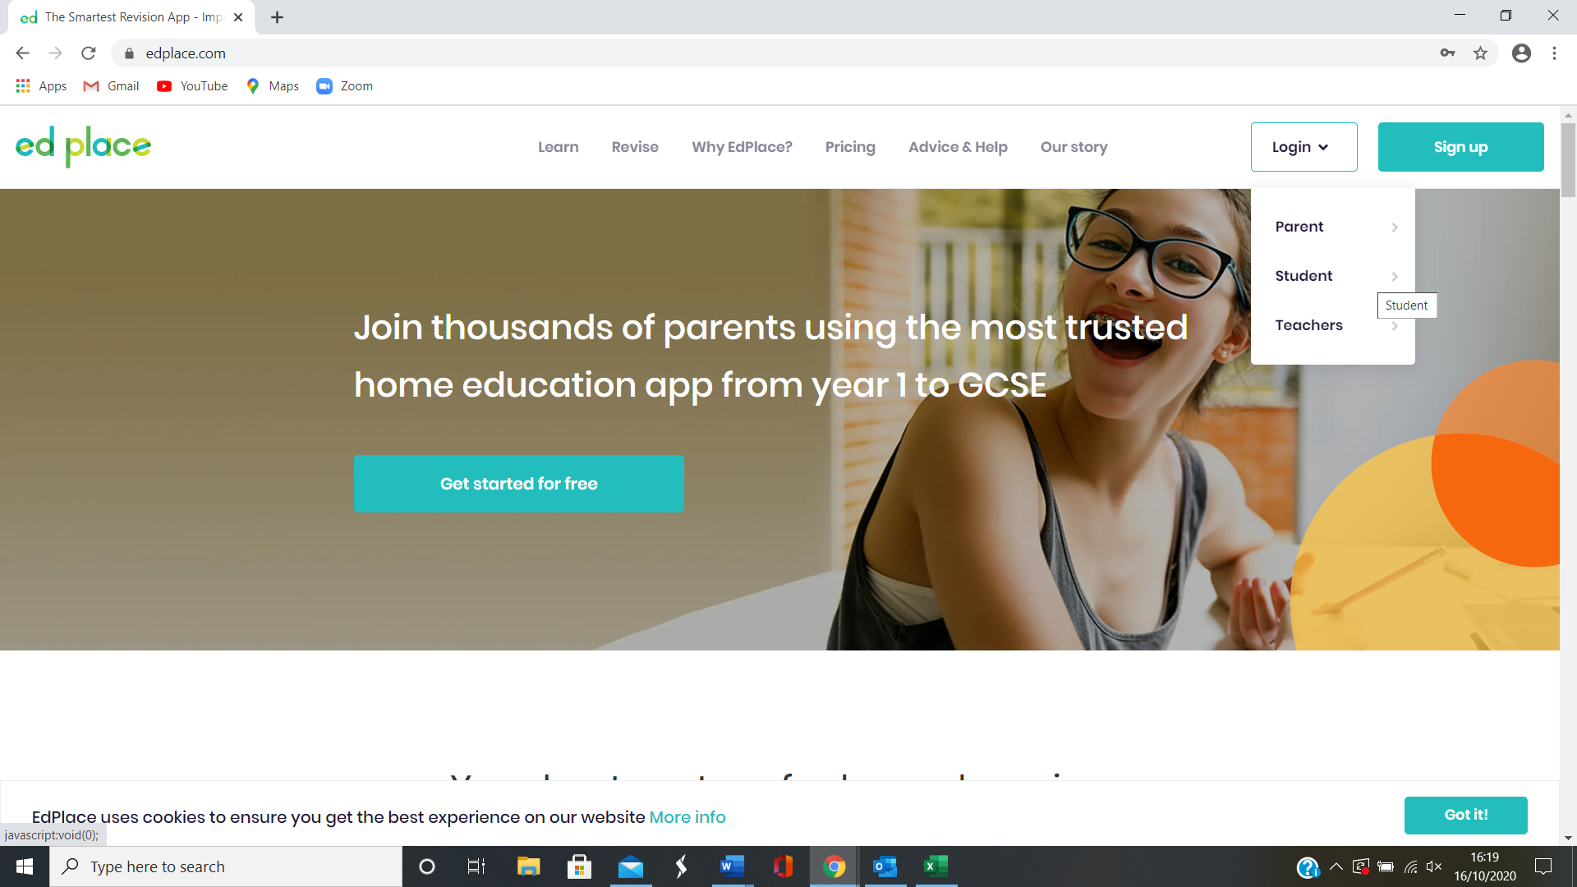

Click on the word student under the login button
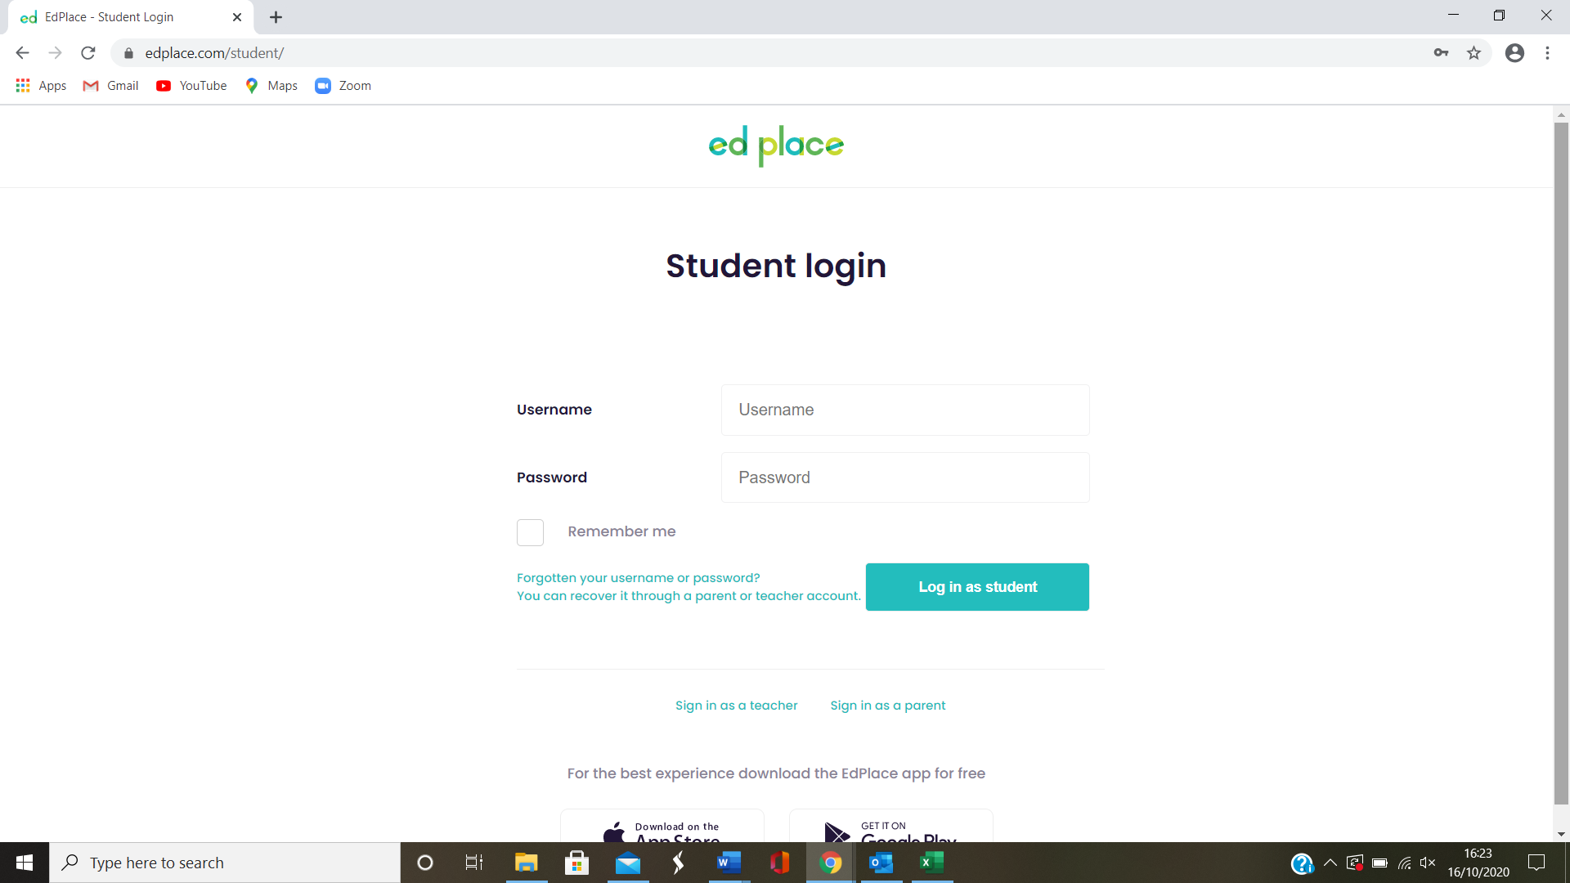
This will then open this page

Your child’s username is their first initial followed by their surname.
For example Cthompson

The password is Moorbrook20

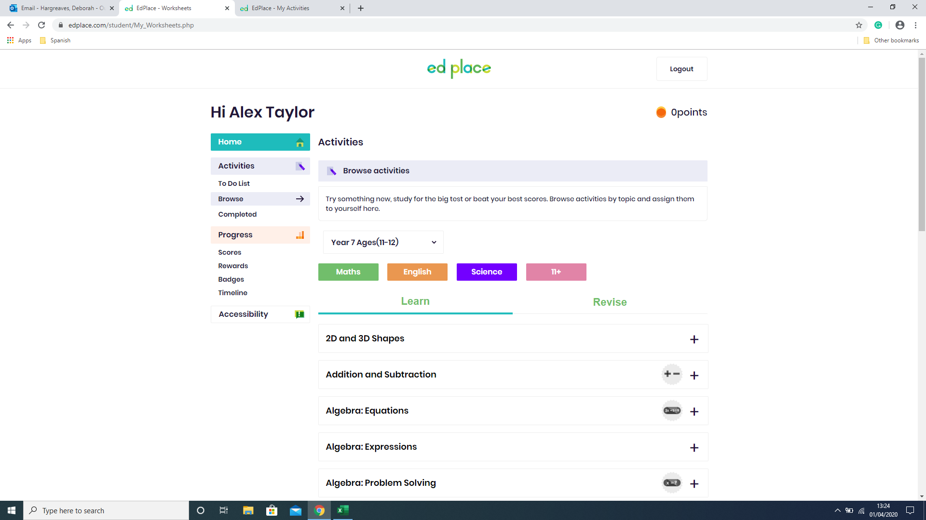
Choose the subject you want to work on
Click on the ‘Browse’ button
Choose the level of work you want to start at
You can earn points and rewards for each worksheet you complete

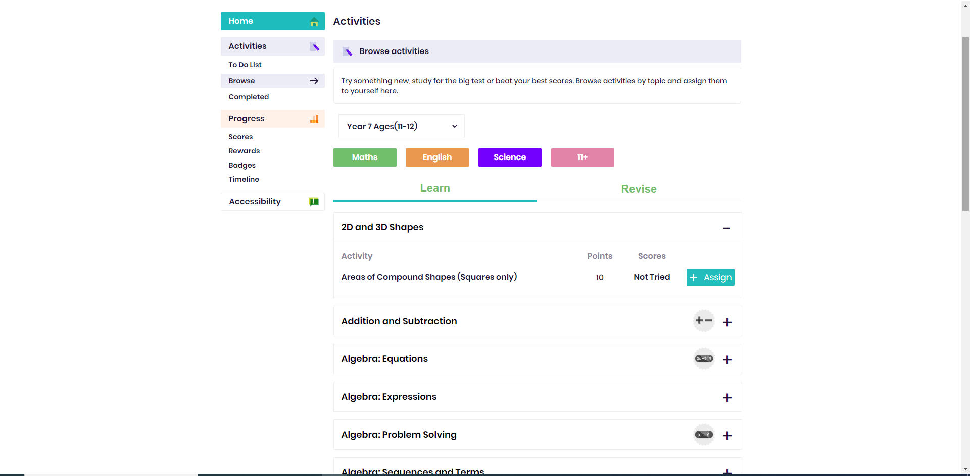
Click ‘Assign’ then ‘Start’
Click on the + symbol
Click on the topic area

