2026/27 College Open Events
College | Courses Offered | Dates | Times
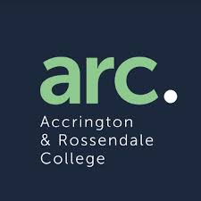  Accrington & Rossendale College (ACROSS) | Apprenticeships  Steps to Success (SEND)  Technical Qualifications  T-Levels | 3rd February 2027 | 5.30pm-7.30pm
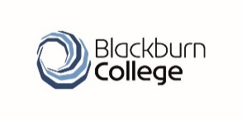Blackburn College | Apprenticeships  A-Levels  Technical Qualifications | 22nd September 2026  14th October 2026  14th November 2026 | 4.30pm-7.30pm
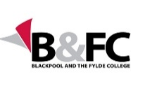  Blackpool & Fylde College | Apprenticeships  Technical Qualifications  T-Levels | 7th November 2026 | 10.30am-2pm
 | Apprenticeships  Technical Qualifications  T-Levels | 4th February 2027 | 5pm-7pm
Blackpool 6th Form | A-Levels  Technical Qualifications  T-Levels | 15th October 2026 | 5.30pm-8pm
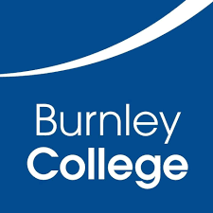  Burnley College | Apprenticeships  A-Levels  Technical Qualifications  T-Levels | 24th September 2026  21st October 2026  17th November 2026  9th February 2027  24th March 2027 | 5.30pm-8pm
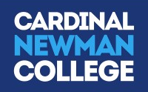  Cardinal Newman College | A-Levels  Foundation Learning (SEND)  Technical Qualifications  T-Levels | 10th October 2026  14th November 2026  6th February 2027 | 10am-1pm
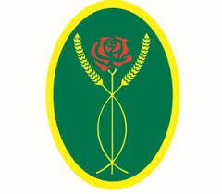Myerscough College | Apprenticeships  Foundation Learning (SEND)  Technical Qualifications | 21st November2026 | 10am-1pm
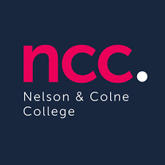  Nelson & Colne College | Apprenticeships  A-Levels  Technical Qualifications  T-Levels | 15th October 2026  11th November 2026 | 5.30pm-7.30pm
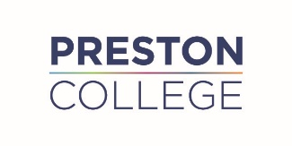  Preston College | Apprenticeships  Technical Qualifications  T-Levels | 30th September 2026  7th November 2026  4th March 2027 | 4pm-7pm
  Runshaw College | Apprenticeships  A-Levels  Technical Qualifications  T-Levels | 26th September 2026 | 10am-2pm
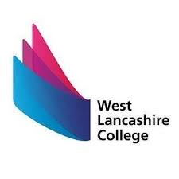  West Lancashire College | Apprenticeships  Technical Qualifications  T-Levels | 12th October 2026  19th November 2026  1st February 2027  29th April 2027 | 4.30pm-7pm

